Up-date on neuro-immune mechanisms involved in allergic and non-allergic rhinitis*

变应性鼻炎和非变应性鼻炎神经免疫机制最新研究进展

Laura Van Gerven1,2, Guy Boeckxstaens3, Peter W. Hellings1,2

1.Department of Otorhinolaryngology, Head & Neck Surgery, University Hospitals Leuven, Leuven, Belgium

2.Laboratory of Experimental Immunology, Catholic University of Leuven, Leuven, Belgium

3.Department of Gastroenterology, University Hospitals Leuven, Leuven, Belgium

Rhinology 50: 227-235, 2012

DOI: 10.4193/Rhino.11.152

*Received for publication: July 13, 2011

Accepted: January 21, 2012

Summary

Non-allergic rhinitis (NAR) is a common disorder, which can be defined as chronic nasal inflammation, independent of systemic IgE-mediated mechanisms. Symptoms of NAR patients mimic those of allergic rhinitis (AR) patients. However, AR patients can easily be diagnosed with skin prick test or allergen-specific IgE measurements in the serum, whereas NAR patients form a heterogeneous group and are difficult to diagnose because of an extensive list of different phenotypes, all varying in severity, underlying etiology and type of inflammation. Characterization of those phenotypes, mechanisms and management of NAR represents one of the major unmet needs in the field of allergic and non-allergic diseases. This review aims at providing a comprehensive overview of the state of the art in classifying the NAR patients and focuses on the neuro-immune mechanisms involved in allergic and non-allergic rhinitis, including reflections on the pathophysiology and the currently available treatment options.

Key words: non-allergic rhinitis, idiopathic rhinitis, capsaicin, neuro-immune mechanisms, nasal hyperreactivity, treatment, pathophysiology

摘要

非变应性鼻炎（NAR）是一种常见的疾病，可定义为慢性鼻炎，与系统性的IgE介导机制无关。非变应性鼻炎患者与变应性鼻炎患者症状相似。然而，变应性鼻炎（AR）患者很容易通过皮肤点刺试验或血清变应原特异性IgE测定诊断出来，而NAR患者是一个异质性的群体，由于其表型种类繁多，严重程度、潜在病因和炎症类型各不相同，因此很难诊断。NAR的表型、机制和管理的特点是变应性和非变应性疾病领域最迫切需要解决的问题之一。本综述旨在全面概述NAR患者分类的最新进展，重点介绍变应性鼻炎和非变应性鼻炎的神经免疫机制，包括对病理生理学和目前可用治疗方案的思考。

Introduction

简介

Chronic rhinitis represents a common condition affecting up to 30% of the Western population (1,2). Patients with persistent rhinitis form a heterogeneous group when it comes to severity of symptoms, underlying etiology and inflammation (2). In an attempt to take into consideration the pathophysiological mechanisms, rhinitis can be classified simplistically into allergic rhinitis, infectious rhinitis and non-allergic non-infectious rhinitis, comprising a large group with rhinitis of known and unknown origin. Indeed, up to 50% of patients with non-allergic non-infectious rhinitis do not have a clear etiology underlying their symptoms and are defined as idiopathic rhinitis (IR). In addition, combined phenotypes may occur, referred to as ‘mixed’ rhinitis (3). According to the ARIA document, terms like ‘vasomotor rhinitis’ should be replaced by IR, as vasomotor mechanisms are ill defined and not always involved in this disease.

慢性鼻炎是一种常见的疾病，影响到多达30%的西方人群。持续性鼻炎患者在症状的严重程度、潜在的病因和炎症方面是一个异质性的群体。从病理生理机制上来说，鼻炎可以简单地分为变应性鼻炎、感染性鼻炎和非变应性非感染性鼻炎，这是一大类鼻炎的已知和未知来源。实际上，高达50%的非变应性非传染性鼻炎患者的症状没有明确的病因，因此被定义为特发性鼻炎（IR）。此外，可能会出现联合的表型，称为“混合性”鼻炎。根据ARIA文件所述，像“血管运动性鼻炎”这样的术语应该用IR代替，因为血管运动机制定义不清，并不总是涉及到这种疾病。

The definition of IR in a subgroup of non-allergic non-infectious rhinitis is largely based on exclusion criteria, i.e. the absence of clinical signs of infection and sensitization to inhalant allergens demonstrated by skin prick test (SPT) results or blood analysis of allergen-specific IgE. Symptoms of IR include nasal secretions, nasal obstruction, sneezing and nasal itching, and therefore mimic allergic rhinitis (AR). However, the majority of these patients do not respond well to anti-allergic treatment. Research on the underlying pathophysiology of IR has moved from autonomic neural disbalance with involvement of the unmyelinated sensory C-fibers containing various neuropeptides to a local inflammatory disorder with inflammation limited to the nasal mucosa with local IgE but without positive SPT and allergen-specific IgE in the blood, called ‘entopy’. So far, entopy can only be demonstrated either by measuring allergen-specific IgE in the nasal cavity or by performing specific allergen provocations (4). A subgroup of patients (30%) with persistent rhinitis symptoms and negative SPT and blood analysis, showed a positive nasal response to specific allergen provocation. This review aims at providing a comprehensive overview of the state of the art in neuro-immune mechanisms involved in allergic and non-allergic rhinitis, including reflections on the pathophysiology and the currently available treatment options.

非变应性非传染性鼻炎中IR的定义主要基于排除标准，即皮肤点刺试验（SPT）结果或变应原特异性IgE的血液分析显示，没有感染和对吸入性变应原过敏的临床表现。IR的症状包括鼻分泌物、鼻塞、打喷嚏和鼻痒，类似于变应性鼻炎（AR）。然而，大多数患者对抗过敏治疗反应不佳。IR潜在的病理生理学研究已经从包含各种神经肽的无髓鞘感觉性C纤维参与的自主神经紊乱转移到局部炎性病变，炎症仅限于鼻黏膜，局部检测有IgE，但SPT阴性、血液中也未发现变应原特异性IgE，称为“entopy”。到目前为止，只有通过检测鼻腔中变应原特异性IgE或进行特异性变应原激发试验才能证明entopy。一组患有持续性鼻炎且SPT和血液分析呈阴性的患者（30%），对特定变应原刺激的鼻反应呈现出阳性反应。本综述旨在全面综述变应性鼻炎和非变应性鼻炎神经免疫机制的研究现状，包括对病理生理学和目前可用治疗方案的反思。

Rhinitis classification

鼻炎分类

Chronic rhinitis can clinically be classified into allergic, infectious and non-allergic non-infectious rhinitis (2).

慢性鼻炎临床上可分为变应性鼻炎、感染性鼻炎和非变应性非感染性鼻炎。

The diagnosis of allergic rhinitis is based on clinical symptoms with suspicion of allergy in combination with a positive skin prick test result or the presence of allergen-specific IgE in the serum. Rhinitis is defined as infectious rhinitis on a clinical base, i.e. when the nasal discharge is discolored and/or purulent. Microbiological detection of microorganisms is not mandatory for a diagnosis of infectious rhinitis. Infectious rhinitis is discriminated from rhinosinusitis (RS) on the basis of typical clinical features of RS like headache, facial pain, smell disorder on the one hand and mucosal pathology at the level of the osteomeatal unit on the other hand (5).

变应性鼻炎的诊断是基于怀疑过敏的临床症状，并结合皮肤点刺试验阳性或血清中检测到变应原特异性IgE。感染性鼻炎的诊断主要基于临床表现，比如鼻腔分泌物变色和/或化脓。微生物检测在感染性鼻炎的诊断中不是强制性的。感染性鼻炎与鼻窦炎（RS）的鉴别一方面是基于鼻窦炎的典型临床特征，如头痛，面部疼痛，嗅觉障碍，另一方面基于窦口鼻道复合体的粘膜病变。

The differential diagnosis of non-allergic non-infectious rhinitis is extensive, including non-allergic rhinitis with eosinophilia syndrome (NARES), also known as local allergy, rhinitis of the elderly, occupational rhinitis, drug induced rhinitis and hormonal rhinitis (6,7) (Table 1). The NARES group probably represents those patients with an allergen-specific immune response confined to the nasal mucosa and negative SPT (6,8). The term ‘entopy’ has been proposed by Powe et al., to describe local allergy in individuals that are considered to be non-allergic (9). The concept of local allergy in IR patients is both intriguing and controversial (10). Some studies have demonstrated the presence of allergen-specific IgE in the nose (9), a positive nasal allergen provocation test (NAPT) (4) and inflammatory cells in a subset of IR patients (11). Other studies do not confirm the involvement of inflammatory cells (12) or the presence of a positive NAPT (13). These seemingly conflicting observations may be the result of differences in nasal challenge techniques and more likely patient selection criteria. Whatsoever, Rondon et al., (4) suggest that 35% of IR patients with a positive NAPT result have evidence of localized nasal specific IgE. Similar percentages are reported by Powe et al. (9), demonstrating that 30% of IR patients have evidence of local allergy. As a consequence, approximately 70% of IR patients may present with symptoms originating from other mechanisms than allergen-driven initiation of an inflammatory cascade.

非变应性非感染性鼻炎的鉴别诊断范围广泛，包括非变应性鼻炎伴嗜酸性粒细胞综合征（NARES），又称局部变态反应，老年性鼻炎、职业性鼻炎、药物性鼻炎和激素性鼻炎（表1）。NARES患者可能是那些过敏原特异性免疫反应局限于鼻黏膜且SPT阴性的患者。Powe等人提出了一个术语“entopy”，用来描述非过敏性个体的局部过敏。IR患者局部过敏的概念既有趣又有争议。一些研究证明，IR组患者鼻腔中存在变应原特异性IgE，鼻过敏原激发试验阳性且存在炎症细胞。其他研究没有证实炎性细胞的参与或鼻过敏原激发试验阳性。这些看似矛盾的观察结果可能是不同的鼻刺激技术和更大可能性的患者选择标准的不同造成的。无论如何，Rondon等人认为，35%鼻过敏原激发试验阳性的IR患者可以检测出鼻腔特异性IgE。Powe等人报告了类似的百分比，表明30%的IR患者有局部过敏的证据。因此，大约70%的IR患者可能出现源自其他机制的症状，而不是变应原诱导的炎症级联反应。

So far, IR remains a diagnosis per exclusionem in patients with mucosal nasal symptoms for which no explanation can be found. Clinical examination with rhinoscopia anterior and nasal endoscopy does not allow the discrimination between the different forms of non-allergic, non-infectious rhinitis.

到目前为止，对存在无法解释的鼻粘膜症状患者，IR仍然是一种排除性诊断。前鼻镜和鼻内窥镜无法区分不同形式的非变应性非感染性鼻炎。

Table 1. Differential diagnosis of non-allergic non-infectious rhinitis.

表1. 非变应性非感染性鼻炎的鉴别诊断。

|  |
| --- |
| Nonallergic rhinitis with eosinophilia syndrome (NARES) / Local Allergy |
| Drug induced rhinitis |
| Hormonal rhinitis |
| Rhinitis of the elderly |
| Occupational rhinitis |
| Idiopathic rhinitis (e causa ignota) |

Nasal hyperreactivity

鼻腔高反应性

Nasal hyperreactivity to various nonspecific stimuli like smoke, strong odours and other irritants is a common and characteristic feature of patients with persistent rhinitis, irrespective of an infectious, allergic or other etiology (14).

鼻腔对各种非特异性刺激如烟雾、强烈气味和其他刺激物的高反应性是持续性鼻炎患者的一个共同特征，无论是感染性、过敏性或其他病因。

Patients with allergic rhinitis usually complain of airway hyperreactivity to non-allergic stimuli both in upper as well as lower airways, generally considered to be a direct result of allergic airway inflammation (15). Histologically, nasal hyperreactivity in AR has been shown to be associated with hyperinnervation of the nasal mucosa with increased expression of the neuropeptides calcitonin gene related peptide (CGRP) and Substance P (SP) in periglandular nerve fibers (a sign of neuronal hyperactivity) (16). Interestingly, AR and IR patients show the same level of mucosal hyperinnervation, suggesting a neuro-inflammatory involvement in both inflammatory nasal conditions. In a study of Braat et al. on pollutional and meteorological factors, IR patients seemed to be more sensitive to minor fluctuations in weather conditions compared to controls (17). In contrast to cold temperatures, humidity or humidity changes was surprisingly less important in the induction of nasal symptoms (17).

变应性鼻炎患者经常诉说上呼吸道和下呼吸道对非变应性刺激的气道高反应性，这种气道高反应性通常认为是气道变应性炎症直接引起。在组织学上，AR的鼻腔高反应性已被证明与鼻粘膜的神经过度支配有关，腺周神经纤维中神经肽降钙素基因相关肽（CGRP）和P物质（SP）表达增加（神经元过度反应的标志）。有趣的是，AR和IR患者表现出相同程度的粘膜神经过度支配，提示在两种鼻炎中均有神经炎症的参与。Braat等人有关污染和气象因素的研究中，与对照组相比，IR患者似乎对天气状况的微小波动更敏感。与低温相比，湿度或湿度改变在诱发鼻部症状方面的作用小得惊人。

Until recently, the most common diagnostic test for measuring nasal hyperreactivity was the nasal histamine provocation, similar to the routinely performed bronchial histamine challenge for evaluation of bronchial hyperreactivity (18). During nasal histamine provocation, increasing doses of histamine (0.125, 0.25, 0.5, 1, 2 and 4 mg/ml) are applied on the nasal mucosa and measurements of nasal cross-sectional diameter or flow start after 1 minute of provocation and continue for 4 minutes. In addition to nasal histamine provocation, Cold Dry Air (CDA) nasal provocation has proven to be an effective tool in quantifying nasal hyperreactivity (19). In 1998, Braat et al. demonstrated that CDA provocations were superior to nasal histamine provocations in discriminating IR patients from healthy controls (18). Sensitivity for CDA was 87% compared with 100% for histamine, but, specificity was 71% for CDA and 0% for histamine. However, more studies on CDA nasal provocation studies are warranted to confirm the validity of this technique and elaborate it as a novel diagnostic tool in rhinology clinic. At present, there is no commercially available CDA device that can be used in clinical practice or for experimental purposes, and the reported studies on CDA have utilized home-made devices. There is now growing consensus about the usefulness of such a technique in daily practice, as nasal hyperreactivity often remains undiagnosed and cannot be taken into account in clinical trials evaluating the effects of current treatments of rhinitis.

直到最近，检测鼻腔高反应性最常见的诊断试验是鼻腔组胺激发试验，类似于评估支气管高反应性的常规支气管组胺激发试验。在鼻部组胺激发试验中，在鼻粘膜上施加递增剂量的组胺（0.125，0.25，0.5，1，2和4 mg/ml），在激发1分钟后开始测量鼻部横截面直径或流量，并持续4分钟。除了鼻部组胺激发试验外，冷干空气（CDA）鼻腔激发已被证明是量化鼻腔高反应性的有效工具。1998年，Braat等人在对IR患者组和健康对照组比较时，发现CDA激发优于鼻组胺激发。CDA的敏感性为87%，组胺为100%，而CDA的特异性为71%，组胺为0%。然而，需要更多有关CDA的鼻腔激发试验研究来证实这一技术的有效性，以进一步完善并将其作为一种新的鼻科临床诊断工具。目前，还没有可用于临床或实验的商用CDA装置，关于CDA的研究报道都是使用自制设备。现在对于这种技术在日常实践中的使用有越来越多的共识，因为鼻腔高反应性经常无法确诊，并且在评估当前鼻炎治疗效果的临床试验中，也不考虑鼻腔高反应性。

Innervation of the nasal mucosa

鼻粘膜的神经支配

Neural regulation in the upper airways is maintained by the sympathetic (adrenergic) and the parasympathetic (cholinergic) nervous systems (Figure 1), which innervate and interact in the nasal mucosa to regulate epithelial, vascular and glandular processes in particular. The sympathetic nerve fibers innervate mainly the vascular structures and to a lesser extent the secretory glands, where they release norepinephrine and neuropeptide Y (NPY) to cause predominantly vasoconstriction and a decrease in nasal secretion (20,21). Parasympathetic fibers innervate both the blood vessels and the exocrine (seromucous and serous) glands of the nasal mucosa, of which glands appear to be more densely innervated. Those nerve fibers release predominantly acetylcholine and neuropeptide transmitters such as vasoactive intestinal peptide (VIP), which increase nasal secretion and induce vasorelaxation leading to nasal congestion under extreme conditions (22). VIP mainly acts through VPAC1 and VPAC2 receptors leading to glandular secretion. Under normal conditions the sympathetic nervous system is dominant ensuring vascular tone.

上呼吸道的神经调节由交感神经（肾上腺素能神经）系统和副交感神经（胆碱能神经）系统支配（图1），它们支配着并相互作用于鼻粘膜，特别是调节上皮、血管和腺突。交感神经纤维主要支配血管结构，有限支配着分泌腺，在那里它们释放去甲肾上腺素和神经肽Y（NPY），主要引起血管收缩和鼻分泌物减少。副交感神经纤维支配着鼻粘膜的血管和外分泌腺（浆液粘液性和浆液性），外分泌腺似乎被许多神经支配着。这些神经纤维主要释放乙酰胆碱和神经肽递质如血管活性肠肽（VIP），在极端条件下增加鼻腔分泌功能并促使血管舒张导致鼻腔充血。VIP主要通过VPAC1和VPAC2受体介导腺体分泌。正常情况下，交感神经系统占主导地位，以保证血管张力。

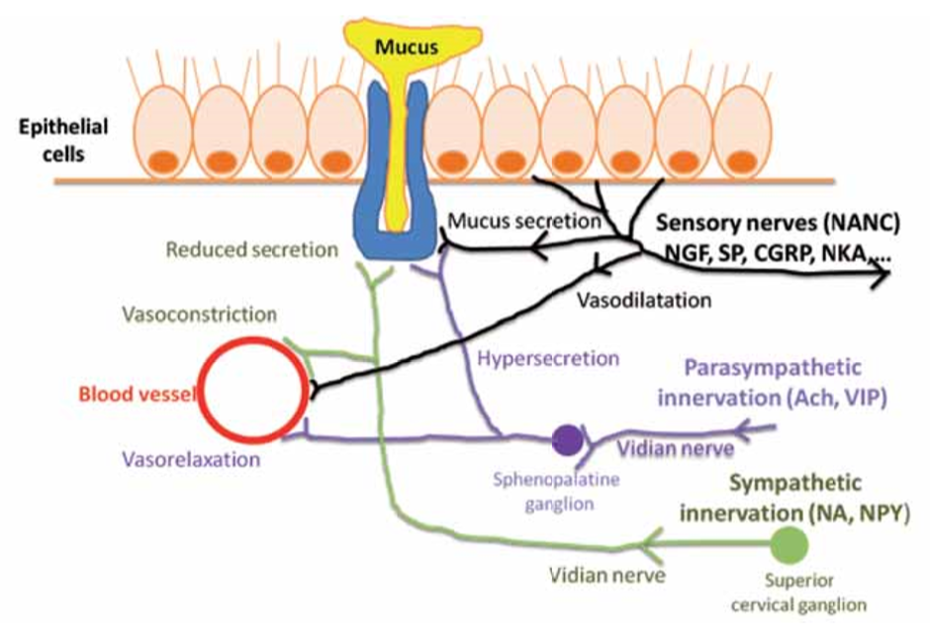

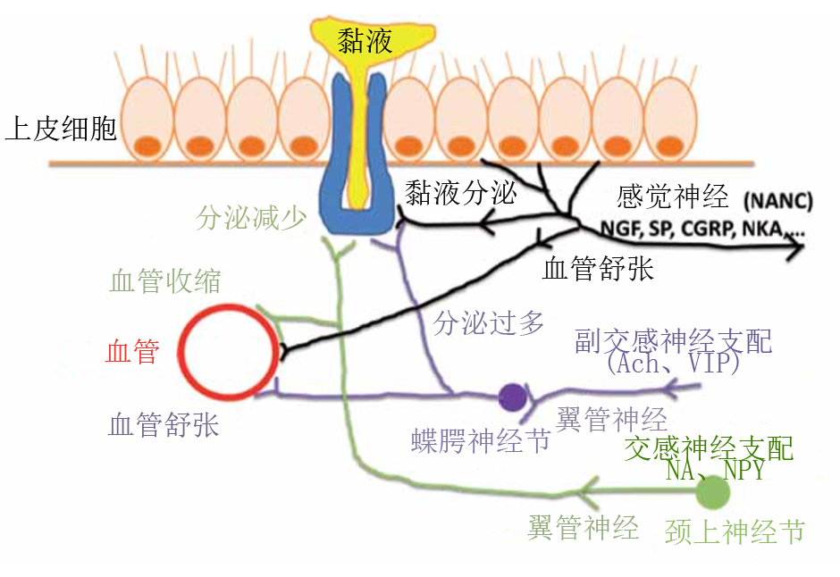

Figure 1. Innervation of the nasal mucosa.

图1. 鼻粘膜的神经支配

Several decades ago, the presence of intraepithelial and perivascular nonadrenergic noncholinergic (NANC) sensory nerve fibers was demonstrated in the human nasal mucosa. These mainly unmyelinated sensory C-fibers contain various neuropeptides including Substance P (SP), calcitonin gene related peptide (CGRP), neurokinin A and B (NKA and NKB) which can be released by unspecific stimuli. In conjunction with the parasympathetic neurons, sensory (NANC) nerves play an essential role in protective nasal clearing reflexes such as sneezing, mucus production and congestion in response to noxious stimuli. These sensory neurons are receiving increasing attention as they are abundantly present and considered to be responsible for the release of neuropeptides in IR, murine naso-bronchial and human naso-ocular interactions in allergic airway disease.

几十年前，在人类鼻粘膜中发现了上皮内的和血管周围的非肾上腺素能非胆碱能（NANC）感觉神经纤维。这些主要的无髓鞘感觉C纤维含有多种神经肽，包括物质P（SP）、降钙素基因相关肽（CGRP）、神经激肽A和B（NKA和NKB），这些神经肽可以通过非特异性刺激释放。感觉（NANC）神经与副交感神经共同作用，感觉（NANC）神经在保护性清鼻反射中起着至关重要的作用，如对有害刺激反应的喷嚏、流涕和堵塞。这些感觉神经元大量存在，并认为在IR中、变应性气道疾病中鼠类的鼻-支气管和人类的鼻-眼作用中负责神经肽的释放，因此越来越受到重视。

Neuro-immune interactions in AR

AR中的神经免疫反应

At present, the pathophysiology of allergic rhinitis is well known from an immunologic point of view. After binding of allergens to the allergen-specific IgE molecules on the surface of resident mast cells in the nasal mucosa and cross-linking of the Fcεreceptor I, mast cells degranulate and release a wide array of pro-inflammatory mediators in sensitized individuals. Mediators like histamine, proteases, prostaglandin (PG)-D2 and leukotriens (LT)-C4 initiate an immune reaction that causes an early and late immune reaction with attraction of granulocytes like eosinophils to the location of allergen deposition. Activated mast cells and other cells of the immune system release pro-inflammatory mediators such as interleukin (IL)-1, IL-4, IL-5, tumor necrosis factor (TNF)-α and interferon (INF)-γ, which all contribute to the inflammatory spectrum of AR. In addition to these immune mediators, neurogenic peptides are also involved in this process (Figure 2). Inflammatory mediators stimulate the afferent sensory nerve endings in the nasal mucosa. Activated nerve endings release neurotrophins (nerve growth factor (NGF), brain derived growth factor (BDGF) and different neuropeptides, like SP, NKA and NKB and CGRP (27). SP and NKA/B are also called ‘tachykinins’. Tachykinins are inactivated by endopeptidases (type 24.11) present in several nasal tissue cells.

目前，变应性鼻炎病理生理学的免疫学的观点是众所周知的。变应原与鼻粘膜中肥大细胞表面的变应原特异性IgE分子结合并与Fcε I受体交联后，肥大细胞脱颗粒并在致敏个体中释放大量促炎介质。组胺、蛋白酶、前列腺素（PG）-D2和白三烯（LT）-C4等介质引发免疫反应，吸引粒细胞如嗜酸性粒细胞到变应原沉积的位置，导致速发相和迟发相免疫反应。活化的肥大细胞和免疫系统的其他细胞释放促炎介质，如白细胞介素（IL）-1，IL-4，IL-5，肿瘤坏死因子-α和干扰素-γ，这些都扩展了AR所涉及的炎症范围。除了这些免疫介质，神经源性肽也参与了这一过程（图2）。炎症介质刺激鼻粘膜中的传入感觉神经末梢。激活的神经末梢释放神经营养因子（神经生长因子（NGF），脑源神经营养因子（BDGF）和不同的神经肽，如SP，NKA，NKB和CGRP。SP和NKA/B也称为速激肽。速激肽是由一些鼻组织细胞中的内肽酶（24.11型）失活的。

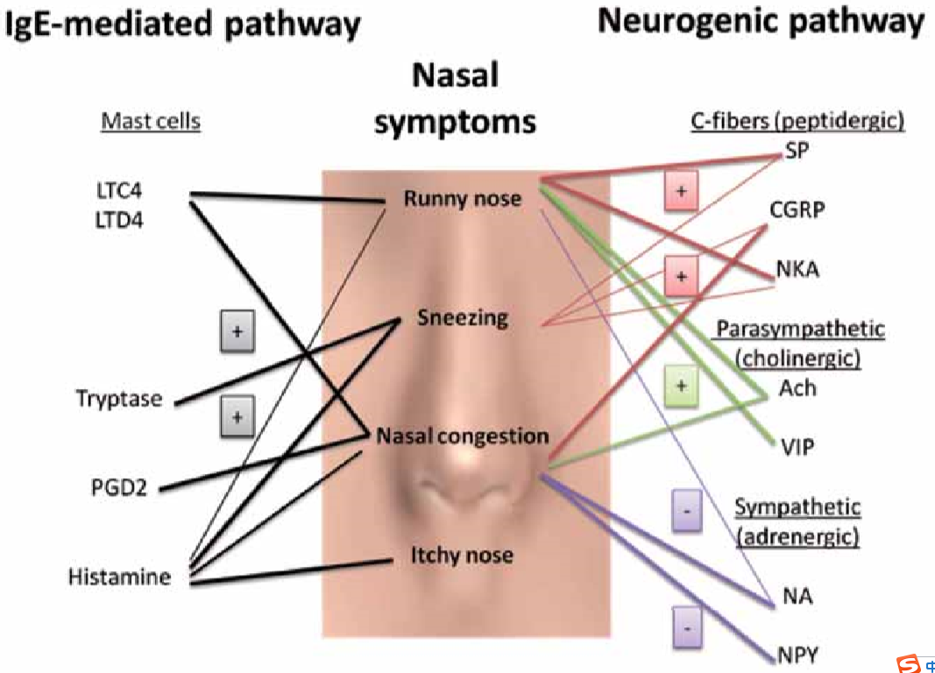

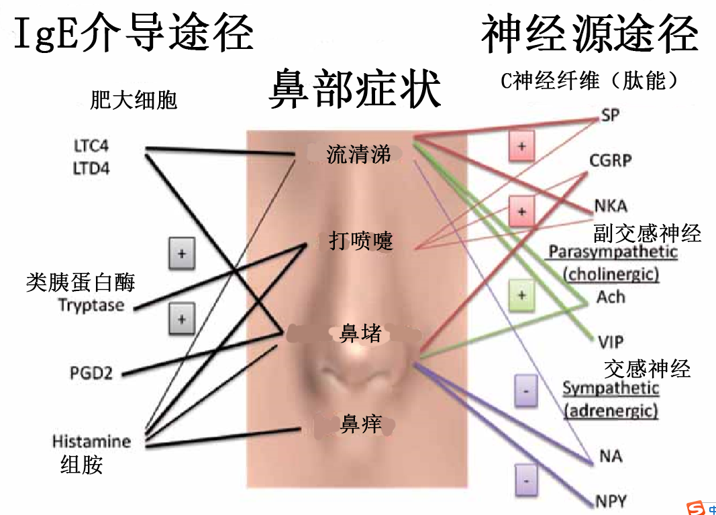

Figure 2. Pathways inducing nasal symptoms.

图2. 引起鼻部症状的途径。

Neurotrophins were initially known for their primary activity, i.e. the growth of peripheral and central nerves. In the mean time, it has become evident that neurotrophins have a variety of immunomodulatory effects on non-neuronal cells including eosinophils and mast cells (neurotrophin receptors present: trkA-C and p75), which also produce neurotrophins (neuronal feedback mechanisms) (30,31). NGF also targets nociceptive fibers leading to increased SP content and dendrite sprouting. Increased levels of NGF have been reported both in serum as well as in nasal lavage fluid of allergic individuals (32). Interestingly, nasal allergen provocation further up-regulated increased NGF in nasal lavage in atopic patients, but not in controls. Additionally, nasal BDNF expression was significantly increased after allergen provocation in AR (33).

神经营养因子最初因其主要活性，即周围神经和中枢神经的生长而为人所知。同时，神经营养因子对包括嗜酸性粒细胞和肥大细胞（神经营养因子受体：TrkA-C和p75）在内的非神经细胞具有多种免疫调节作用，这些细胞也产生神经营养因子（神经元反馈机制）。NGF还以痛觉神经为靶点，导致SP含量增加和树突生长。在过敏个体的血清和鼻灌洗液中均有NGF水平升高的报道。有趣的是，在变应性鼻炎患者组的鼻灌洗中，鼻部过敏原的刺激进一步促进了NGF的表达，而在对照组中则没有。在AR组中，过敏原刺激后鼻部BDNF表达显著升高。

The neuropeptides SP and NKA are both released by afferent nerves upon activation, and bind their NK1 and NK2 receptor respectively, present on epithelial and endothelial cells. Activation of these receptors results in glandular activation, leukocyte recruitment and activation of different immune cells. CGRP release results in vasodilatation upon binding to its receptor on endothelial cells. Besides stimulated afferent nerves, different studies have demonstrated that immune cells like eosinophils, neutrophils and dendritic cells are also a source of tachykinins such as SP (34). Mast cells are not a source of SP, but express the NK1 receptor. Forsythe et al. demonstrated neuroimmuneinteraction within the human lung (35). The activation of mast cells, eosinophils, sensory nerve endings and epithelial cells is responsible for the entire spectrum of symptoms, characteristic for AR (Figure 3). Okamoto et al. showed that SP upregulates mRNA for the pro-inflammatory cytokines IL-1β, IL-3, IL-5, IL-6, TNF-α and IFN-α in the human nasal mucosa, which is an additional stimulus to allergic inflammation (36). The long-term eff ects of SP on human mast cell expression of the Fcε-receptorI was investigated by McCary et al., who showed a SP-mediated downregulation of receptor expression (37).

神经肽SP和NKA均由传入神经激活后释放，并分别与上皮细胞和内皮细胞上的NK1和NK2受体结合。这些受体的激活导致腺体激活、白细胞募集和不同免疫细胞的激活。降钙素基因相关肽释放后与内皮细胞上的相关受体结合导致血管扩张。除了刺激传入神经外，不同的研究表明，免疫细胞如嗜酸性粒细胞、中性粒细胞和树突状细胞也是速激肽如SP的来源。肥大细胞不是SP的来源，但可以表达NK1的受体。Forsythe等人证实了人肺内的神经免疫作用。肥大细胞、嗜酸性粒细胞、感觉神经末梢和上皮细胞的激活参与了全部症状，这是AR的特征（图3）。Okamoto等人表明SP有助于人鼻粘膜中促炎细胞因子IL-1β，IL-3，IL-5，IL-6，TNF-α和IFN-α的mRNA表达，这些表达是过敏性炎症的另一种刺激。McCary等人研究了SP对人肥大细胞Fcε I受体表达的长期影响，显示SP介导的受体表达下降。

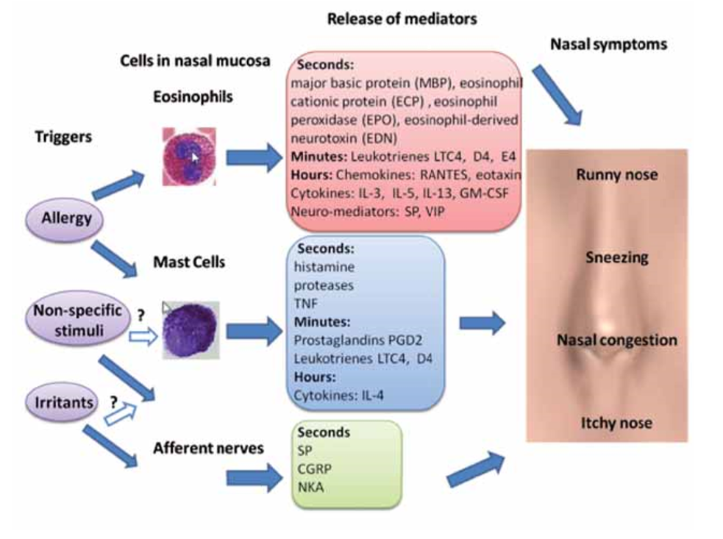

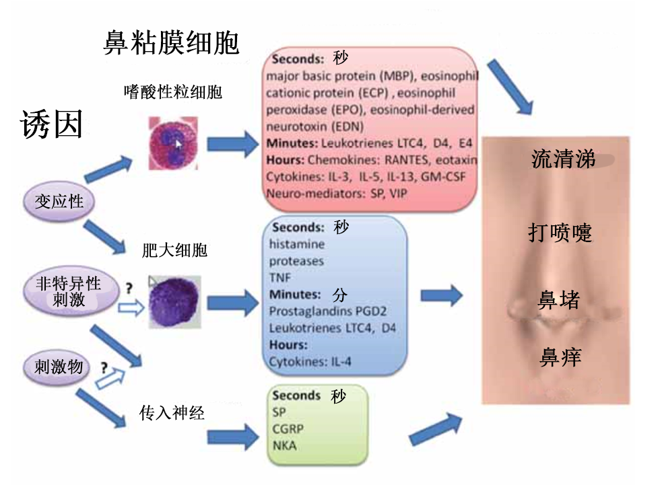

Figure 3. Triggers and cells involved in inducing rhinological symptoms in AR and IR patients.

图3. 诱发AR和IR患者鼻症状的因素和细胞。

Few reports examined the effects of anti-allergic agents on neuropeptides. Shinoda et al., showed a decrease in SP concentration in nasal lavage fluid in allergic patients with seasonal rhinitis after intake of oral antihistamines (38). Recently, Schäper et al., showed significantly lower baseline levels of SP after intranasal Fluticasone propionate treatment (14 days treatment) in nasal lavage fluid of patients with persistent allergic rhinitis (39). This effect was accompanied by an improvement in the clinical symptoms. Different mechanisms were proposed to contribute to this decreased release of neuropeptides caused by intranasal steroids. Corticosteroids can down-regulate tachykinin receptors and neuropeptides synthesis in neurons and in other immune cells (40). Additionally, corticosteroids are able to up-regulate the synthesis of neuropeptide-degrading enzymes (endopeptidases type 24.11) (41). Besides the neuropeptides, other short amino acid peptides like endothelins (21 amino acids) can play a role in the induction of symptoms in AR since the expression of endothelins is enhanced in glands and inflammatory cells in chronic inflammation and endothelin-1 induces the secretion of proinflammatory mediators in human nasal mucosa. However, more studies are needed in order to determine the real importance of this endothelin cascade in nasal inflammation (42).

关于抗过敏药对神经肽作用的报道很少。Shinoda等人发现，口服抗组胺药后，季节性变应性鼻炎患者鼻灌洗液中SP浓度降低。最近，Schaper等人在使用丙酸氟替卡松喷鼻治疗（14天治疗）后，持续性变应性鼻炎患者的鼻灌洗液中SP的水平显著降低。随着这种效果而来的是临床症状的改善。不同的机制均认为有助于减少鼻内类固醇引起的神经肽释放。皮质类固醇可降低神经元和其他免疫细胞的速激肽受体和神经肽合成。此外，皮质类固醇能够促进神经肽降解酶的合成（24.11型内肽酶）。除神经肽外，其他短氨基酸肽如内皮素（21个氨基酸）可在诱发AR的症状中发挥作用，因为在慢性炎症时内皮素在腺体和炎症细胞中的表达增强，并且内皮素-1可引起人鼻粘膜中促炎介质的分泌。然而，需要更多的研究来确定这种内皮素级联反应在鼻部炎症中的真正重要性。

Neuro-immune interactions in IR

IR中的神经免疫相互作用

As the name suggests, the etiology of IR remains largely unknown. Several mechanisms have been postulated to explain the pathophysiology of IR. The two most plausible hypotheses are non-IgE- mediated inflammatory responses and/or neurogenic responses.

顾名思义，IR的病因在很大程度上仍然是未知的。已经有几种假设机制提出来解释IR的病理生理学。两个最合理的假设是非IgE介导的炎症反应和/或神经源性反应。

Inconsistent data have been published on the non-IgE-mediated inflammatory responses as mentioned before. Powe et al., demonstrated an increased number of epithelial activated mast cells, increased mucosal eosinophils and increased IgE+ cells in the nasal airways of IR patients (11), which could not be confirmed by the groups of Van Rijswijk and Blom et al. (12,43). The major difficulty in comparing the few studies published on this topic is the inconsistency in defining this patient group. NARES patients for example were not excluded in Powe’s study and can explain the discrepancy between reports.

关于先前所述的非IgE介导的炎症反应，已经发表了不一致的数据。Powe等人发现IR患者鼻道上皮活化的肥大细胞数量增加，粘膜嗜酸性粒细胞增多，IgE+细胞增多(11)，这一点没有被Van Rijswijk和Blom等人的研究证实。(12，43)。关于这一主题发表的少数研究中的主要困难在于对这一患者组的定义不一致。例如，NARES患者并没有排除在Powe的研究中，这样可以解释不同报告之间的差异。

Recently, more evidence for neurogenic mechanisms involved in IR was obtained. Activation of the sensory C-fibers of peptidergic neurons can lead to local release of neuropeptides (antidromic release) in the human nasal mucosa and thus can primarily trigger symptoms of IR, similar to AR (Figure 2). This hypothesis was corroborated by Lacroix et al., who reported an increased concentration of neuropeptides in a group of IR patients (44). Similarly, Heppt et al., demonstrated a denser innervation of SP-containing sensory nerves in the nasal mucosa of IR patients (45). Similar observations are reported in occupational rhinitis and drug induced rhinitis (46). In some forms of drug induced rhinitis, neurogenic mechanisms have been proposed to play a crucial role (47). For example, drugs such as guanethidine and methyldopa, principally sympatholytic agents, elicit their effects by down-regulation of the sympathetic nervous system, leading inevitably to symptoms of nasal congestion (47).

近年来，有关IR神经机制的证据逐渐增多。肽能神经元感觉C纤维的激活可导致神经肽在人鼻粘膜中的局部释放（逆行释放），可触发类似AR的IR症状（图2）。这一假设得到了Lacroix等人的证实，他们报道了一组IR患者神经肽浓度的增加。类似地，Heppt等人在IR患者的鼻粘膜中显示了含SP的感觉神经更密集的神经支配。在职业性鼻炎和药物性鼻炎中也有类似的观察报道。在某些类型的药物性鼻炎中，神经机制被认为起着至关重要的作用。例如，胍乙啶和甲基多巴等药物主要是交感神经抑制剂，通过抑制交感神经系统来发挥作用，从而不可避免地导致鼻塞症状。

Current treatment options for IR

IR的当前治疗方案

Intranasal corticosteroids (INS)

鼻内皮质类固醇（INS）

Today, as recommended by current guidelines, almost all patients with severe persistent rhinitis, independent of the underlying pathophysiology, are initially treated with intranasal corticosteroids (INS) (48). Due to their potent anti-inflammatory potential, INS have a good clinical efficacy in nasal inflammation. However, clinicians will agree that not all patients with IR benefit from INS. Indeed, inconsistent results have been reported on the efficacy of INS in the treatment of IR patients, suggesting that inflammation may not be an important underlying mechanism in all patients. In studies showing a favorable effect of INS in IR patients (49), NARES patients/patients with local IgE were not excluded, possibly explaining their positive results. In contrast, Blom et al., showed only limited or no benefit of INS in IR (50).

目前，正如现在的指南推荐的那样，大部分持续性鼻炎患者，不考虑潜在的病理生理，患病初期推荐使用鼻内喷激素治疗。由于其强效抗炎潜力，鼻内喷激素在鼻部炎症方面有很好的临床疗效。然而，临床医师并不认为所有IR患者都会从鼻内喷激素中获益。事实上，关于INS治疗IR患者疗效的报告结果并不一致，这表明炎症可能不是所有患者的重要潜在机制。在显示INS对IR患者有良好效果的研究中，NARES患者/局部IgE患者没有被排除在外，这可能解释了他们的阳性结果。相比之下，Blom等人在IR中显示INS的作用有限或没有作用。

Antihistamines

抗组胺药

Two double-blind placebo-controlled trials have been published showing a therapeutic effect of azelastine nasal spray in IR patients with nasal obstruction and or rhinorrhea when treated for 15 or 21 days (51,52). In spite of their efficacy, the precise mode of action remains to be elucidated. The older antihistamines often have some anticholinergic side effects possibly contributing to the therapeutic effect.

已经发表的两个双盲安慰剂对照试验，显示了氮卓斯汀鼻喷雾剂治疗鼻塞和/或鼻漏患者15天或21天（51，52）的疗效。尽管它们有效，但确切的作用方式仍有待阐明。老一代抗组胺药往往有一些抗胆碱能的副作用，可能对治疗效果有帮助。

Ipratropium bromide

异丙托溴铵

Ipratropium bromide (IB) is an anticholinergic drug, effective in reducing the severity and duration of the rhinorrhoea in IR (53). IB is considered a safe molecule and is recommended for use in the elderly with bilateral nasal secretions as presenting symptom and without other endonasal pathology.

异丙托溴铵（IB）是一种抗胆碱能药物，能有效降低IR中鼻出血的严重程度和持续时间（53）。IB被认为是一种安全的分子，推荐用于双侧鼻腔有分泌物且无其他鼻内病变的老年人。

Nasal application of botulinum toxin A (BTA)

A型肉毒毒素（BTA）的鼻腔应用

Nasal hypersecretion due to IR can often not be treated sufficiently by conventional medication (50). In a placebo-controlled study, Rohrbach et al. showed that BTA applied with a sponge brought subjective long-lasting reduction of hypersecretion in 46% of the patients with therapy-resistant IR (54). The fact that not all patients treated reported a subjective improvement, can be explained by the knowledge that acetylcholine does not play a major role in all patients with nasal hypersecretion. Baraniuk et al. postulated that BTA also influenced other neuropeptides in nasal secretion (26), explaining the observed reduction of nasal secretion by BTA in some of the ipratropium bromide resistant patients (25).

由于IR引起的鼻腔分泌物过多通常不能通过常规药物充分治疗。在一项安慰剂对照研究中，Rohrbach等人结果表明，在46%的耐药IR患者中，BTA与海绵联合应用可导致分泌物过多的持久性主观降低。并非所有接受治疗的患者都报告有主观改善，这一事实可以解释为乙酰胆碱在所有鼻腔分泌过多患者中并不起主要作用。Baraniuk等人假设BTA也影响了鼻分泌物中的其他神经肽，解释了一些对异丙托品耐药的患者中观察到的BTA鼻分泌物减少的现象。

Capsaicin (Table 2, table of all published data)

辣椒素（表2，所有公布数据的表）

Since 1991, several studies have demonstrated that repeated nasal applications of capsaicin have a therapeutic effect in 70% - 80% of IR patients (55-57). Most studies reported a long-lasting relief of symptoms ranging from 6 to 9 months (43). Capsaicin, the pungent ingredient of the plants of the genus Capsicum is known for its ability to activate/desensitize a specific subset of primary sensory C- and A-δ fibers (58). Recently, Davies et al., showed that capsaicin can initiate TRPV1-dependent cell death in neuron-like cells (59). This finding of an apoptosis-like process triggered by capsaicin can explain the long-lasting effects of capsaicin treatment in IR patients. Capsaicin binds the TRPV1 receptor, also known as ‘pain receptor,’ present on these C-fibers. TRPV1 is part of the superfamily of transient receptor potential (TRP) cation channels. TRPV1 is highly selective for capsaicin and other vanilloid-like compounds. In addition, TRPV1 is activated by acidic pH and temperatures > 42°C (60). This intriguing receptor family appears to respond to an amazing variety of environmental stimuli, including noxious irritants, environmental pollutants and temperature. Activation of TRPV1 by capsaicin can cause release of neuropeptides (antidromic release) and subsequently rhinorrhea, nasal blockage and sneezing (Figure 2). This initial aggravation of nasal complaints is indeed reported by patients receiving nasal capsaicin application.

自1991年以来，一些研究表明，鼻腔反复应用辣椒素对70%-80%的IR患者有治疗效果。大多数研究报告指出症状的缓解范围为6至9个月。辣椒素，辣椒属植物的刺激性成分，以其激活/脱敏初级感觉C-和A -δ纤维的特定亚群而闻名。最近，Davies等人发现辣椒素可以引起神经元样细胞中TRPV1依赖性细胞死亡。这一由辣椒素引发类似凋亡过程的发现可以解释辣椒素治疗IR患者的长期效果。辣椒素与这些C纤维上的TRPV1受体结合，也被称为“疼痛受体”。TRPV1是瞬时受体电位（TRP）阳离子通道超家族的一部分。TRPV1对辣椒素和其他类香草酸化合物具有高度的选择性。此外，TRPV1可以在pH酸性和温度>42°C（60）时激活。这个有趣的受体家族似乎在对各种环境刺激做出反应，包括有毒刺激物、环境污染物和温度。辣椒素激活TRPV1可导致神经肽释放（逆行释放），继而导致鼻漏、鼻塞和打喷嚏（图2）。这种鼻部症状的最初加重确实是在鼻用辣椒素的患者组中报告的。

The hypothesis that hyperreactivity of the sensory, unmyelinated C-fibers is the underlying pathophysiology in IR can offer an explanation for the beneficial effect of this treatment. Lacroix et al., reported an increased concentration of neuropeptides in a group of IR patients, which support this hypothesis (44). However, Blom et al., could not find reduction of those sensory C-fibers in the nasal mucosa in IR patients after successful capsaicin treatment (43).

感觉性无髓C纤维的高反应性是IR的病理生理学基础，这一假说可以解释这种治疗的有益效果。Lacroix等人报告了一组IR患者中神经肽浓度的增加，这支持了这一假设。然而，Blom等人在辣椒素治疗成功后，并没有发现IR患者鼻粘膜中的感觉C纤维减少。

In placebo-controlled studies, no therapeutic effect for capsaicin was found in patients with house dust mite AR patients (61,61). This observation indirectly supports the idea that neurogenic inflammation is secondary to the IgE-mediated pathway in AR, whereas the efficacy of capsaicin in IR may be due to predominance or dysfunction of the peptidergic system in the absence of nasal inflammation.

在安慰剂对照研究中，辣椒素对屋尘螨AR患者没有治疗作用。这一观察间接支持了神经源性炎症是继发于AR中IgE介导的途径的观点，而辣椒素在IR中的疗效可能是由于在没有鼻腔炎症的情况下，肽能系统的优势或功能障碍。

Until know, no further research has been done on TRPV1 receptors on other structures of the nasal mucosa. Mast cells and epithelial cells in the skin of prurigo nodularis patients express TRPV1 suggesting that capsaicin is not solely interacting with sensory nerve fibers and thus other mechanism of action may be involved (63). Better insight in the mechanism of action of capsaicin is mandatory to develop more specific and more potent agents to treat.

迄今，还没有进一步研究TRPV1受体在鼻黏膜其他结构上的作用。结节性痒疹患者皮肤中的肥大细胞和上皮细胞表达TRPV1，表明辣椒素不仅仅与感觉神经纤维相互作用，还可能涉及其他作用机制。更好地了解辣椒素的作用机制，是开发更具体、更有效的治疗药物的必由之路。

Conclusion

结论

At present, we are still at the beginning of understanding the heterogeneity of the different pathophysiological mechanisms involved in NAR. The neural mechanisms involved in NAR and AR have been an underappreciated area of research so far. Understanding the role of neuropeptides is mandatory for the elaboration of novel treatment options. Following the currently available treatments for NAR, new therapeutic approaches consist of the development of substances that intervene in the neurogenic inflammatory processes and inhibit the synthesis/ release of neuropeptides.

目前，我们对NAR所涉及的不同病理生理机制的异质性的认识尚处于起步阶段。到目前为止，NAR和AR中的神经机制一直是一个未被重视的研究领域。了解神经肽的作用是制定新的治疗方案的必要条件。在目前可用的NAR治疗方法之后，新的治疗方法包括开发干预神经源性炎症和抑制神经肽合成/释放。

Conflict of interest

利益冲突

None

无

1、皮肤点刺试验

百度百科

皮肤点刺试验是将少量高度纯化的致敏原液体滴于患者前臂、再用点刺针轻轻刺入皮肤表层。如患者对该过敏原过敏，则会于十五分钟内在点刺部位出现类似蚊虫叮咬的红肿块，出现痒的反应，或者颜色上有改变。我们基本上就能够比较确定过敏性疾病的存在。皮肤点剌试验现为欧洲国家及美国公认最方便、经济、安全、有效的过敏原诊断方法，其优点为安全性及灵敏度均高，患者无痛楚，就如被蚊叮一样，而且患者及医生都可以立刻知道检验结果。

试验的基本原理

原理是当有某种变应原进入皮肤时，对某些物质有速发型过敏反应的患者，立即特异性地引起皮肤内的肥大细胞脱颗粒，释放组胺等活性物质，导致局部毛细血管扩张（红斑），毛细血管通透性增强（水肿、风团），阳性者表示对该抗原过敏。该方法采用组胺作阳性对照，以计算相对的反应强度，是一种有效测定过敏性皮肤病的特应性（对一种或多种变应原敏感）的方法。

2、脱髓鞘

是指髓鞘形成后发生的髓鞘损坏，脱髓鞘疾病是以神经髓鞘脱失为主，神经元包体及轴突相对受累较轻为特征的一组疾病，包括遗传性和获得性两大类。遗传性脱髓鞘疾病主要指脑白质营养不良，以儿童多见。获得性脱髓鞘疾病又分为中枢性和周围性两类。周围性脱髓鞘疾病中最具代表性的为急性和慢性炎症性脱髓鞘性多发性神经病。中枢性脱髓鞘疾病包括多发性硬化和急性播散性脑脊髓炎等。

无髓神经纤维（unmyelinated nerve fiber）：神经元较长的突起常被起绝缘作用的髓鞘和神经膜所包裹，构成有髓神经纤维，若只被神经膜所包裹则称无髓神经纤维。周围神经的神经膜是只被施万细胞的核和质膜所包裹。周围神经系统的施万细胞沿着轴突连接成连续的鞘,一个施万细胞可包裹多条轴突,但纤维较细,表面光滑,不形成髓鞘,无郎飞结.在脊髓灰质的第二板层中较多。

神经元胞质（胞浆)的延长部分称为“神经纤维”，也叫“突起”。神经纤维的粗细各异，直径约在十分之几微米（1微米等于1/1000毫米)至100微米之间。有的很短，只有几微米；有的很长，可达1米左右。外有绝缘性髓鞘包着的，叫有髓鞘纤维；没有明显髓鞘的，叫无髓鞘纤维。纤维内充满半流动性的神经浆，浆内有微管、微丝、线粒体、内质网等，具有维持突起生长和运输的作用。许多平行的神经纤维集合成束，即是神经